The Jericho Forum Declares Success
Announcement on 21 Oct 2013
Central Hall Westminster, London UK

Overview
Ten years ago, the Jericho Forum set out on a focused mission - to evangelise the issues, problems, solutions and provide thought-leadership around the emerging business and security issues of de-perimeterisation, with the aim of one day being able to declare “job-done".

That day has now arrived. Today, de-perimeterisation is an established "fact" touching all areas of modern business. Widely understood and quoted by the entire industry, it has become part of the everyday computing and security lexicon.

With our mission accomplished, we are ready to "declare success", celebrate it as a landmark victory, and pass our legacy of de-perimeterisation achievements and publications, as well as relevant on-going work, into the continued good care of The Open Group.

As part of this celebration we are presenting awards to leading members who have made outstanding contributions to shaping, steering and driving the Jericho Forum through our decade of de-perimeterisation. We are also recognising fellow information security visionaries, including press and analysts, who have made notable contributions to the Jericho Forum's decade of successful achievements.

The occasion will be live-streamed and recorded for playback worldwide.
We also look forward to blogs and tweets (using hashtag #JFsuccess) to mark this event.

Headline Achievements
- Formed in Oct 2003 as a CISO-level group of information security thought-leaders, and formally established as a Forum on 14 Jan 2004. Sun-setting on 1st Nov 2013
- A decade showing the way forward on critical information security challenges impacted by de-perimeterisation
- De-perimeterisation - the breakdown of corporate boundaries as business demands for increasing connectivity with business partners, suppliers, customers, outworkers, undermined traditional corporate perimeter security, bypassing perimeter firewalls.
The corporate perimeter was falling down.
- Predicted advances in modern business computing, including Cloud, BYOD and the Internet of Things all requiring connectivity through corporate perimeters.
- A legacy of landmark publications, including
  - De-perimeterisation Vision & Business Case
  - Jericho Forum Commandments, and associated Self-Assessment Scheme
  - Collaboration Oriented Architecture Framework
  - The “Cloud Cube” Model
  - Identity Management: Identity Commandments, Videos, Ecosystem
  - Data Protection
- Collaborations with, and use by;
  - Cloud Security Alliance, on CS Guidance, Cloud Control, Trusted Cloud
  - ENISA on Cloud Computing Benefits, Risks and Security
  - NIST on Security Reference Architecture SP 500-299 (Trusted Cloud)
  - US Dept of Homeland Security on Trusted Identities in Cyberspace
- Evangelised the business case for de-perimeterisation throughout the decade:
  - in many major Conferences and Industry Events around the world
  - in widely published industry press, analyst articles, LinkedIn, blogs, tweets
- Established the Jericho Forum as a globally recognised brand and logo.

Notable Events through the Decade 2004-2013
2001 - The “de-perimeterisation” word coined [Royal Mail’s Jon Measham]
2003 - Oct: Paul Simmonds & David Lacey on de-perimeterisation at RSA Europe
2003 - Oct: De-perimeterisation hits headlines: “IT Chiefs Call for Security Rethink”
2004 - Jan: Jericho Forum formed, hosted by The Open Group
2004 - Dec: Open Group Jericho Forum becomes an Open Group Managed Consortium
2005 - Feb: Published de-perimeterisation Vision & Business Case
2005 - Apr: Held first Jericho Conference alongside UK InfoSecurity & SC Awards
2006 - Registered “Jericho” as a Registered Trade Mark
2006 - Apr: Published first two Requirements papers - on Architecture, Protocols
2006 - Apr: Published Jericho Forum Commandments
2006 to 2008 - Published many more security architecture requirements papers
2009 - Jan: Published Collaboration Oriented Architectures (COA) Framework
2009 - Apr: Published Cloud Cube Model paper
2009 - Jun: Jericho Commandments demonstrated as valid for Cloud Computing
2010 - Mar: Published & launched Jericho Commandments Self-Assessment Scheme
2011 - May: Published Identity Commandments, based on user-centric identity
2011 - Nov: Joint editorship with CSA for CSA Guidelines v3
2012 - Jan: Jericho Forum submission to the US NSTIC initiative
2012 - Jul: Joined the US DHS’s NSTIC Identity Ecosystem Steering Group (IDESG)
2012 - Aug: Published Identity Key Concepts - in five 4-minute videos
2012 - Oct: Published Data Protection strategy, based on data-centric security
2012 - Nov: Published Identity Ecosystem Guide
2013 - May: Developed Managing Network Resources paper
2013 - Sep: Developed Smart Data & Trust Ecosystem papers
2013 - Oct: de-perimeterisation mission achieved - declare success & sunset
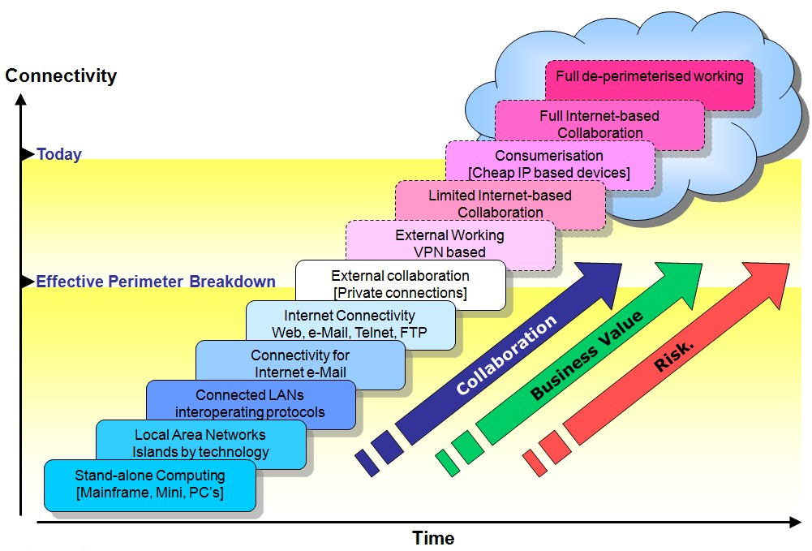
De-perimeterisation Timeline

