Technical Standard – v1.8
OSIMM – The Open Group Service Integration Maturity Model


Copyright © 2009, The Open Group
All rights reserved.
No part of this publication may be reproduced, stored in a retrieval system, or transmitted, in any form or by any means, electronic, mechanical, photocopying, recording, or otherwise, without the prior permission of the copyright owner.
It is fair use of this standard to use the terms, names, labels, concepts, etc. contained or described within it. The intent of publication of the standard is to encourage its widespread use.
This standard has not been verified for avoidance of possible third-party proprietary rights. In using this standard, usual procedures to ensure the respect of possible third-party intellectual property rights should be followed.

Document Type
Document Title
ISBN:
Document Number:

Published by The Open Group, <Month> <Year>.

Comments relating to the material contained in this document may be submitted to:
The Open Group
Thames Tower
37-45 Station Road
Reading
Berkshire, RG1 1LX
United Kingdom
or by electronic mail to:
TTogedit@opengroup.orgTT

Contents
1 Introduction 1
1.1 Objective 1
1.2 Overview 1
1.3 Conformance 2
1.4 Terminology 3
Future Direction 7
2 The Model 8
2.1 Overview 8
2.2 Maturity Levels 10
2.2.1 Level 1: Silo 10
2.2.2 Level 2: Integrated 10
2.2.3 Level 3: Componentized 10
2.2.4 Level 4: Service 10
2.2.5 Level 5: Composite Services 11
2.2.6 Level 6: Virtualized Services 11
2.2.7 Level 7: Dynamically Re-Configurable Services 11
2.3 Dimensions 12
2.3.1 Business 12
2.3.2 Organization & Governance 12
2.3.3 Methods 12
2.3.4 Applications 12
2.3.5 Architecture 13
2.3.6 Information 13
2.3.7 Infrastructure 13
2.4 Service Foundation Levels 13
2.5 Assessment Questions and Maturity Indicators by Dimension 14
2.5.1 Extending the Base OSIMM Model 14
2.5.2 Maturity Indicators to Assessment Question Mapping 14
3 Business Dimension - Base Model 15
3.1 Business Dimension - Base Model Maturity Indicator 15
3.2 Business Dimension - Assessment Questions 16
3.3 Business Dimension - Maturity Indicator to Attribute Mapping 17
4 Organization & Governance Dimension – Base Model 20
4.1 Organization & Governance - Base Model Maturity Indicator 20
4.2 Organization & Governance - Assessment Questions 21
4.3 Organization & Governance Dimension – Maturity Indicator to Attribute Mapping 21
5 Methods Dimension – Base Model 26
5.1 Method Dimension - Base Model Maturity Indicator 26
5.2 Method Dimension - Assessment Questions 27
5.3 Method Dimension - Maturity Indicator to Attribute Mapping 27
6 Application Dimension – Base Model 30
6.1 Application Dimension - Base Model Maturity Indicator 30
6.2 Application Dimension - Assessment Questions 31
6.3 Application Dimension - Maturity Indicator to Attribute Mapping 31
7 Architecture Dimension – Base Model 36
7.1 Architecture Dimension - Base Model Maturity Indicator 36
7.2 Architecture Dimension - Assessment Questions 37
7.3 Architecture Dimension - Maturity Indicator to Attribute Mapping 37
8 Information Dimension – Base Model 41
8.1 Information Dimension - Base Model Maturity Indicator 41
8.2 Information Dimension - Assessment Questions 42
8.3 Information Dimension - Maturity Indicator to Attribute Mapping 43
9 Infrastructure & Management Dimension – Base Model 47
9.1 Infrastructure & Management Dimension - Base Model Maturity Indicator 47
9.2 Infrastructure & Management Dimension - Assessment Questions 48
9.3 Infrastructure & Management Dimension - Maturity Indicator to Attribute Mapping 48
10 The OSIMM Assessment Method 52
10.1 Overview 52
10.2 OSIMM Assessment Steps 54
10.2.1 Identify the Pain Points, Scope and Business Goals 54
10.2.2 Extend the OSIMM Model 54
10.2.3 Assess Current State 54
10.2.4 Determine Future State 54
10.2.5 Identify the Gaps and Determine the Road map 54
A Appendix A – Example Assessment 56
A.1 Business Objective 56
A.2 Analysis 56
A.3 Recommendations 57
B APPENDIX B – Benefits of Moving to Higher Maturity Levels 62
B.1 Benefits of moving from Silo to Integrated 62
B.2 Benefits of moving from Integrated to Componentized 62
B.3 Benefits of moving from Componentized to Services 62
B.4 Benefits of moving from Services to Composite Services 63
B.5 Benefits of moving from Services to Virtualized Services 63
B.6 Benefits of moving from Virtualized Services to Dynamically Re-Configurable Services 63
C References 64

Preface
The Open Group
The Open Group is a vendor-neutral and technology-neutral consortium, whose vision of Boundaryless Information Flow will enable access to integrated information within and between enterprises based on open standards and global interoperability. The Open Group works with customers, suppliers, consortia, and other standards bodies. Its role is to capture, understand, and address current and emerging requirements, establish policies, and share best practices; to facilitate interoperability, develop consensus, and evolve and integrate specifications and Open Source technologies; to offer a comprehensive set of services to enhance the operational efficiency of consortia; and to operate the industry's premier certification service, including UNIX certification.
Further information on The Open Group is available at TTwww.opengroup.orgTT.
The Open Group has over 15 years' experience in developing and operating certification programs and has extensive experience developing and facilitating industry adoption of test suites used to validate conformance to an open standard or specification.
More information is available at TTwww.opengroup.org/certificationTT.
The Open Group publishes a wide range of technical documentation, the main part of which is focused on development of Technical and Product Standards and Guides, but which also includes white papers, technical studies, branding and testing documentation, and business titles. Full details and a catalog are available at TTwww.opengroup.org/bookstoreTT.
As with all live documents, Technical Standards and Specifications require revision to align with new developments and associated international standards. To distinguish between revised specifications which are fully backwards-compatible and those which are not:
- A new Version indicates there is no change to the definitive information contained in the previous publication of that title, but additions/extensions are included. As such, it replaces the previous publication.
- A new Issue indicates there is substantive change to the definitive information contained in the previous publication of that title, and there may also be additions/extensions. As such, both previous and new documents are maintained as current publications.
Readers should note that updates – in the form of Corrigenda – may apply to any publication. This information is published at TTwww.opengroup.org/corrigendaTT.
This Document
This document is the Technical Standard for the Open Group Service Integration Maturity Model (OSIMM). It has been developed and approved by The Open Group.
OSIMM Abstract
The Open Group SOA Integration Maturity Model (OSIMM) provides consultants and IT practitioners a means to assess an organization’s Service Oriented Architecture (SOA) maturity level. It defines a process to create a roadmap for incremental adoption which maximizes business benefits at each stage along the way. The model consists of seven levels of maturity and seven dimensions of consideration that represent significant views of business and IT capabilities where the application of SOA principles are essential for the deployment of services. The OSIMM acts as a quantitative model to aid in assessment of current state and desired future state of SOA maturity.

Trademarks
Boundaryless Information FlowPP^{™PP} and TOGAFPP^{™PP} are trademarks and Making Standards WorkPP^{®PP}, The Open GroupPP^{®PP}, and UNIXPP^{®PP} are registered trademarks of The Open Group in the United States and other countries.
The Open Group acknowledges that there may be other brand, company, and product names used in this document that may be covered by trademark protection and advises the reader to verify them independently.

Acknowledgements
The Open Group gratefully acknowledges the contribution of the following people in the development of this document:
- Ali Arsanjani, IBM – Original SIMM Mapping
- Tony Carrato, IBM
- Jorge Diaz, IBM
- Jack Fujieda, Regis Inc.
- Henry Hendrikx, Capgemini
- Alex Heublien, HP
- Kerrie Holley, IBM – Original SIMM Mapping
- Dave Ings, IBM
- Heather Kreger, IBM
- Chris Moyer, EDS
- Andras Szakal, IBM – Work Group Chair, Model Extensions
- Srinivasan Vembakkam, IBM
- Steve Wolf – Marriott
- Members of The Open Group’s SOA Work Group

Introduction

Objective
This document is The Open Group’s Service Integration Maturity Model (OSIMM)) version 0.1. It specifies:
- A model against which the degree of service integration maturity of an organization can be assessed; and
- A process for assessing the current and desired degree of service integration maturity of an organization, using the model.

Overview
Service-Oriented Architecture (SOA) is an architectural style that supports service-orientation. A service is a business task with an externalized service description that often represents a contract between a provider and a consumer. As organizations adopt SOA and the use of services as the fundamental structuring element of their architecture, they increasingly encounter the need to assess where they are in their migration path and how best to achieve the expected benefit derived from integrating and investing in greater levels of SOA maturity.
The Open Group Service Integration Maturity Model (OSIMM) helps an organization create a roadmap for its incremental transformation towards more mature levels of service integration, in order to achieve increasing business benefits associated with higher levels of maturity. OSIMM is used to determine which organizational characteristics are desirable in order to attain a new level of maturity. This will also help determine whether problems occurring at the current level of service integration maturity can be solved by evolving to a higher level.
OSIMM is offered to the industry as a standardized model to help organizations guide their SOA transformation journey. A standard maturity model enables enterprises to benchmark their SOA levels and develop roadmaps for transformation to assist their planning. It can also be used by vendors to position their services and software against these benchmarks. OSIMM may also serve as a framework for the transformation process that can be customized to suit the specific needs of organizations and assessments. This process consists of the following steps:
- prepare the OSIMM assessment framework,
- determine the initial level of maturity,
- determine the target level of maturity
- identify the transformation path necessary for the organization to achieve the desired level of maturity.
OSIMM structures the assessment of the organization’s current state in service integration and flexibility (including service orientation) and of its desired or future state for different lines of business or enterprise, taking into account pain points in flexibility or integration that need to be improved. It provides a model for assisting the organization in determining its architectural strategy when adopting service orientation, including the creation of an architectural roadmap for initiatives in legacy transformation, integration with one or more packaged applications, application renovation and development, and systems integration. This roadmap helps to determine the scope, focus and incremental steps for different parts of the organization in order to transform them towards a higher level of service orientation and service integration, with justifications in terms of anticipated business benefits. OSIMM provides a framework for surfacing insights and identifying IT improvements in terms of component development, service integration, SOA and IT governance.
OSIMM focuses on increasing levels of flexibility in seven aspects of an organization or enterprise: business, organization and governance, methods and processes, application portfolio, architecture, information, infrastructure and operational management. Focus on these aspects aids the adoption of a more flexible business by planning integration in advance and constructing business models, processes, applications and infrastructure mindful of flexibility.
The OSIMM base model is specified by this document. The base model defines the OSIMM framework and the assessment process. The base model is designed to be extended by allowing customers and consulting organizations to add additional maturity indicators. By extending the model, the maturity assessment can be focused on the adoption of evolving industry frameworks, new techniques or organizational imperatives. The authors of the OSIMM standard fully expect that a database of OSIMM extensions will evolve, providing greater insight into the process of SOA adoption.
OSIMM may be used to conduct assessments of the current and desired levels of maturity for an enterprise or line of business within an organization and design a plan of action to transform from the current to the desired levels. For example, an organization may wish to apply OSIMM to a particular set of applications in the organization’s portfolio. A decision is made to partition the large number of applications into a small number of partitions, based upon affinity to business function. The current state of each partition is then assessed using the maturity model. Based upon the pain points, business drivers and goals, the target state for each partition is established. The transformation increment for each partition (which may be different for each partition) is then defined in order to achieve the target state for that partition.

Conformance
This specification describes the OSIMM SOA maturity model and a corresponding SOA maturity assessment process. This document describes the characteristics of architectures necessary to achieve a particular level of SOA maturity. Maturity models and Maturity model assessments must use at least the terminology, matrix, dimensions, levels, and attributes described herein in order to be conformant with this specification. Particular maturity model indicators are not mandated for conformance. An exemplary process for assessment that conforms to this specification is provided in Section 10 but is not mandated for conformance.

Terminology
This terminology section provides definition for terms that have a specialized meaning within OSIMM or are prone to alternative interpretations.
Adoption: The detailed steps that are required to achieve a transformation.
These steps may include the adoption of new technologies, methods, processes and integration techniques, and the establishing of corporate initiatives, IT directives, technical standards, Executive Councils, Architecture Boards and Governance.
Architectural style:
A combination of distinctive features in which architecture is performed or expressed.
The SOA architectural style has the following distinctive features:
- It is based on the design of the services – which mirror real-world business activities – comprising the enterprise (or inter-enterprise) business processes.
- Service representation utilizes business descriptions to provide context (i.e., business process, goal, rule, policy, service interface, and service component) and implements services using service orchestration.
- It places unique requirements on the infrastructure – it is recommended that implementations use open standards to realize interoperability and location transparency.
- Implementations are environment-specific – they are constrained or enabled by context and must be described within that context.
- It requires strong governance of service representation and implementation.
- It requires a “Litmus Test", which determines a “good service”.²
BPEL: Business Process Execution Language Standard.
http://docs.oasis-open.org/wsbpel/2.0/OS/wsbpel-v2.0-OS.html
Business Service:
A self-contained piece of business functionality that may be called through a well-defined standard interface and protocol, independent of implementation platform, and managed under a contract specifying availability levels and quality of service.
Dimension (or View):
A major axis along which the SOA maturity level of an organization may be measured.
The dimensions represent significant views of the business and IT environment where the application of SOA principles can have a major effect. An organization may be at a different maturity level on each dimension, and the overall maturity level of the organization may be aggregated from the dimension levels. Dimensions are to a first approximation independent, but there are relationships between them.
Domain:
A subdivision of a dimension, representing a more specific aspect of that dimension, along which the organization may be measured as to its SOA maturity level. Again these represent aspects where SOA principles can have an effect. Each domain has one or more maturity indicators at each maturity level, and the sequence of indicators identifies a pathway from less to more mature SOA. The overall maturity level of a dimension is aggregated from the individual maturity levels of its domains.
Dynamic Configuration:
The ability of a system to look up new services, based upon the matching of a required specification, and to configure itself to call these new services without the development of new programming code.
Master Data Model:
A virtualized federated data model service with a master view
Maturity: The creation of characteristics and behavior in an organization, as a result of transformation and adoption, that permit it to operate better in accordance with its business goals.
For example, an organization may have put in place processes for the identification of new services, which will facilitate the creation of services in the future. The nature of the characteristics and behavior created in the organization defines the service integration maturity level, and this is contained within the OSIMM model.
The concepts of SOA transformation, adoption, and maturity are interrelated; transformations are broken down into adoptions, which create new characteristics: a sign of maturity.
Maturity Indicator (or Characteristic):
A characteristic of the business or IT that may be measured and assessed by asking specific questions. Each maturity indicator is associated with a specific domain (and by implication a dimension) and maturity level; if the indicator is assessed as true then this is evidence for the domain being at that level of maturity.
Maturity Level Attribute:
Observed characteristics of a maturity indicator within a dimension for each maturity level
Maturity Model:
A means of and scale for evaluating and assessing the current state of maturity.
A maturity model also provides a means for developing a transformation roadmap to achieve a target state of maturity from a given current state of maturity. It quantifies the relative growth of certain salient aspects within various dimensions typically within, but not limited to organizational boundaries.
Open Group Service Integration Maturity Level (OSIMM):
A model that enables estimation of the degree to which an organization or enterprise has taken up the principles of SOA within their IT and business. There are 7 levels, level 1 being the least take up and level 7 being the greatest take up. Higher degrees of maturity are likely to lead to a higher degree of agility in the business, but are not necessarily “better”, as each organization may have an ideal level of maturity depending upon their business requirements and business and IT context.
Organization:
Any entity interested in SOA adoption for the purpose of deploying service-enabled business processes, including governments, businesses, lines of business, projects, an enterprise, service ecosystem or an industry
Service:
A logical representation of a repeatable business activity that:
- has a specified outcome (e.g., check customer credit; provide weather data, consolidate drilling reports)
- Is self-contained
- May be composed of other services
- Is a “black box” to consumers of the service²
Service Level Agreement (SLA):
A contract mostly used between service providers and their users to establish availability, volume, and response time agreements
Service Orientation:
A way of thinking in terms of services and service-based development and the outcomes of services.²
SOA: An architectural style that supports service orientation.¹
(SOA) Eco-system:
A group of one or more organizations that are co-dependent on one another for achieving business goals by executing services that may leverage another company’s business processes.
Transformation:
A high level change from one organizational state to another in order to support business imperatives and goals. Transformations may be business transformations (for example a reduction in the number of customer calls) or IT transformations (for example the introduction of support for markets in different geographies). It may be necessary to perform business and IT transformations in parallel in order to ensure that the business activities are aligned with the IT activities.
Virtualized Service:
A service that is hidden behind a “façade”, so that the caller of the service does not call it directly but via a proxy that intercepts the call and routes it to a real service based upon considerations such as load and availability.
Can: Describes a permissible optional feature or behavior that an assessment may have.
Must: Describes a feature or behavior that is mandatory for an assessment. An assessment that conforms to this document shall include this feature or behavior.
Should: For an assessment that conforms to this document, describes a feature or behavior that is recommended but not mandatory.

Future Direction
- Development of an OSIMM maturity indicator repository.
- Development of an OSIMM case study repository.

The Model

Overview
The Open Group Service Integration Maturity Model (OSIMM) gives organizations the ability to measure the maturity levels of IT systems and applications. In addition, it provides guidance on how to achieve the levels of maturity needed to realize particular SOA-related business benefits.
The OSIMM has seven dimensions across seven maturity levels.
OSIMM defines a set of dimensions, representing different views (e.g. business, architectural) of an organization. These are the Business, Organization, Methods, Application, Architecture, Information and Infrastructure views.
The seven SOA maturity levels are Silo, Integrated, Componentized, Services, Composite Services, Virtualized Services and Dynamically Re-Configurable Services.
The maturity level of each dimension is assessed by matching maturity indicators to maturity level attributes. The total assessment of maturity indicators for all the dimensions provides a holistic view of the service integration maturity level of the organization.
The OSIMM maturity matrix which defines the maturity dimensions and levels is shown in Figure 2:1.
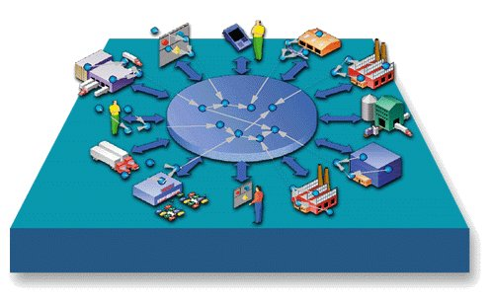Figure 2.1: OSIMM Maturity Matrix
Silo
Level 1
Services
Level 4
Composite
Services
Level 5
Virtualized
Services
Level 6
Level 7
Dynamically
Re-Configurable
Services
Componentized
Level 3

Integrated
Level 2
Modules
Services
Process Integration via Service
Dynamic Application Assembly
Components
Objects
Applications
Structured Analysis & Design
Service Oriented
Modeling
Service Oriented
Modeling for Infrastructure
Business Grammar Oriented
Modeling
Component Based Development
Object Oriented
Modeling
Methods
Isolated Business
Line Driven
Business provides & consumes services
Outsourced Services
BPM & BAM
Business capabilities via context aware services
Componentized Business Functions
Business Process Integration
Business View
Composed
Business Services
Service Oriented
Modeling
Applications comprised of composite services
LOB Platform
Specific
Project Based SOA Environment
Virtual SOA Environment:
Sense and Respond
Context-aware
Event-based:
Sense & Respond
Common Reusable Infrastructure
Enterprise Standards
Infrastructure &
Management
Monolithic Architecture
Emerging
SOA
Grid Enabled SOA
Dynamically Re-Configurable Architecture
Component
Architecture
Layered Architecture
Architecture
SOA
Common SOA Environment
Ad hoc LOB IT Strategy and Governance
Emerging SOA governance
SOA and IT Infrastructure Governance alignment
Governance via Policy
Common Governance Processes
IT
Transformation
Governance & Organization
SOA and IT Governance Alignment
Application Specific Data Solution
Information as a Service
Virtualized Data Services
Semantic Data Vocabularies
Canonical
Models.
LOB Specific
(Data subject areas established)
Information
Enterprise Business Data Dictionary & Repository
Service Foundation Levels
The columns of the matrix correspond to the maturity levels, and the rows correspond to the dimensions. Each cell in the matrix defines the maturity level for each of the dimensions in each column. The overall SOA maturity of an organization is assessed by identifying its maturity level in each dimension.
For example, consider the cell Information x Silo, with the label “Application Specific Data Solution”. Maturity attributes are mapped to maturity indicators within OSIMM (see section 2.5). If the maturity attributes suggest that the Silo level maturity indicators are present for a particular assessed application or system, then the maturity of the Information Dimension is considered to be Siloed (Level 1: Siloed), so the assessed application or system is characterized as having an Application Specific Data Solution.
Each Dimension may be assessed in a similar way, leading to a level assessment for each Dimension of Business View, Organization etc. The overall picture, in terms of the assessed maturity level for each Dimension may itself be assessed to provide a view of the overall maturity level of the organization.

Maturity Levels
At the heart of OSIMM are the seven levels of enterprise business and IT service-integration maturity. Each of the seven levels reflects a possible abstract state of an organization in terms of its maturity in the integration of its services (business and/or IT) and SOA solution.

Level 1: Silo
Individual parts of the organization are developing their own software independently, with no integration of data, processes, standards or technologies. This severely limits the ability of the organization to implement business processes that require co-operation between the different parts, and the IT systems cannot be integrated without significant manual intervention, such as re-keying and re-interpretation of data.

Level 2: Integrated
Technologies have been put in place to communicate between the silos, and to integrate the data and interconnections. The construction of an IT system that integrates across different parts of the organization becomes possible. However integration does not extend to common standards in data or business processes. Therefore to connect two systems, it requires a, possibly complex, conversion of the data, operations and protocols used by these systems. Each such connection may require bespoke code and adapters, leading to a proliferation of software that is difficult to manage and complex to code. It is therefore not easy to develop or automate new business processes.

Level 3: Componentized
The IT systems in the silos have been analyzed and broken down into component parts, with a framework in which they can be developed into new configurations and systems. There may also be some limited analysis of the business functionality into components. Although components interact through defined interfaces, they are not loosely coupled,, which limits agility and interoperability between different segments of the organization (or even different organizations within the business “eco-system”). This causes difficulties in development and deployment of shared business processes. Business and infrastructure components are discrete and re-useable through code and EAI reuse techniques. However, they are often replicated and redundant.

Level 4: Service
Composite applications are built from loosely-coupled services. The way that services may be invoked is based upon open standards and is independent of the underling application technology. Services run on an IT infrastructure that is supported by the appropriate protocols, security mechanisms, data transformation and service management capabilities. The services may therefore interoperate across all of the parts of the organization and even across different organizations within the eco-system, and are often managed by assigning responsibilities for managing SLAs to segments of the organization. The business functionality has been analyzed in detail and is broken down into services residing within a business architecture that ensures that services will interoperate at the business level. In addition, it is possible to define the services via a specification language, such as WSDL or SCA that unambiguously defines the operations performed by the service, permitting the construction of a catalogue of services. The combination of IT and service architectures permits the construction of systems based upon these services, operating right across the organizations in the ecosystem. However, at this stage the composition of services and flow of control within a composite application are still defined by developers writing bespoke code, rather than by a declarative flow language. This limits the agility of the development of new business processes as services.

Level 5: Composite Services
It is now possible to construct a business process for a set of interacting services, not just by bespoke development, but by the use of a composition or business process modeling language, such as BPEL, to define the flow of information and control through the individual services. This permits the assembly of services into composite business processes, which may be short or long running, without significant construction of code. Thus the design and development of services is agile, and may be performed by developers under the close guidance of business analysts.

Level 6: Virtualized Services
The business and IT services are now provided through a façade, a level of indirection. The service consumer does not invoke the service directly, but through the invocation of a “virtual service”. The infrastructure performs the work of converting the virtual invocation into a physical call of the real service, and may as part of this conversion change the address, the network, the protocol, the data and the synchronization pattern that is contained in the call. Such conversions may be a complex service in their own right, such as the transformation of data from one data model to another. The virtual service thereby becomes more loosely coupled from the infrastructure on which it is running, permitting more opportunities for the composition of services. This is in contrast to the lower levels of service maturity, where the service is more closely coupled to the infrastructure. Although virtualization has been used in non-SOA systems, this level extends the concept (and advantages) of virtualization to services.

Level 7: Dynamically Re-Configurable Services
Prior to this level, the business process assembly, although agile, is performed at design time by developers (under the guidance of business analysis and product managers) using suitable tooling. Now this assembly may be performed at runtime, either assisted by the business analysts via suitable tooling, or by the system itself. This requires the ability to access a repository of services and to query this repository via the characteristics of the required services. In its simplest form, these characteristics may have been defined in advance, restricting the system to selecting and locating specific instances of services.

Dimensions
An organization’s level of SOA maturity can be assessed across the following set of dimensions which are essential indicators for effective SOA adoption.

Business
The Business dimension is focused on the business architecture: i.e. the organization’s current business practices and policies, how business processes are designed, structured, implemented and executed. The Business dimension also addresses how the cost of IT capabilities is allocated across the enterprise, and how well the IT capabilities support the flexibility of the business, agility and service-level agreements. The business dimension includes IT strategy. And thus includes the necessary value proposition for moving from one maturity level to a higher level maturity level. A discussion of these value propositions are in Appendix B.

Organization & Governance
The Organization & Governance dimension is focused on the structure and design of the organization itself and the necessary measures of organizational effectiveness in the context of an SOA and SOA governance. The Organization aspect is focused on organizational structure, relationships, roles and the empowerment necessary to adopt a service- oriented strategy. This includes the types and extent of skills, training and education that are available within the organization. Governance is associated with formal management processes to keep IT activities, service capabilities, and SOA solutions aligned with the needs of the business. Governance guides many aspects of the other maturity dimensions, including how management is structured and costs are allocated.

Methods
The Methods dimension is focused on the methods and processes employed by the organization for its IT and business transformation, and the organization’s maturity around the Software Development Life Cycle such as the use of requirements management, estimation techniques, project management, quality assurance processes, design methodologies and techniques and tools for designing solutions.

Applications
The application dimension is focused on application style, structuring of the application and functional decomposition, reusability, flexibility, reliability and extensibility of the applications, understanding and uniform use of best practices and patterns, whether multiple applications have been created to serve different lines of business with essentially the same functionality, and the availability of enterprise schema and object models.

Architecture
The Architecture dimension is focused on the structure of the architecture which includes topology, integration techniques, enterprise architecture decisions, standards and policies, web services adoption level, experience in SOA implementation, SOA compliance criteria, and typical artifacts produced.

Information
The Information dimension is focused on how information is structured, how information is modeled, the method of access to enterprise data, abstraction of the data access from the functional aspects, data characteristics, data transformation, service and process definition, handling of identifiers, security credentials, knowledge management, business information model, and content management.

Infrastructure
The Infrastructure dimension is focused on the organization’s infrastructure capability, service management, IT operations, IT management and IT administration, how SLAs are met, how monitoring is performed, and what types of integration platforms are provided.

Service Foundation Levels
The first three layers of the OSIMM maturity model, Silo, Integrated, and Componentized, are referred to as the Service Foundation Levels. Service-orientation is much easier to achieve if business functions are developed as discrete business components that are componentized, location independent, and loosely-coupled from the underlying runtime environment. The Service Foundation Levels can be seen as recommended prerequisites for service enabling a legacy environment (or even aggregating existing services). While it is possible to provide services over poorly structured legacy environments, it may compromise the success of the SOA solution. Green-field SOA applications may be an exception and not require the same steps to achieve service-orientation as reusing legacy business functions. Services developed using web services and other service enabling technologies should also meet the maturity characteristics defined by the Service Foundation Levels.

Assessment Questions and Maturity Indicators by Dimension
The maturity indicators are assessed by a set of questions that elicit customer pain points and current SOA-related practices. The OSIMM base model includes a set of assessment questions and maturity indicators that can be used as provided or extended to determine an organizations SOA maturity.

Extending the Base OSIMM Model
The standard set of assessment questions and maturity indicators are defined below as the initial base OSIMM model. The base OSIMM model can be extended by adding additional maturity indicators, assessment questions and corresponding attribute mappings, for example to encompass maturity indicators specific to an industry or enterprise. Industry extensions may be standardized to provide a common baseline to measure SOA maturity against adoption of specific industry SOA frameworks (such as retail and financial frameworks).
Maturity indicator weighting is used to provide a method to weight multiple maturity indicators within a dimension – for example when organizational or industry maturity indicators are added to the base model. Maturity indicator weighting is based on a 10 point scale by maturity level. Additional maturity indicators would be allocated a maturity weight based on a portion of the total possible dimension maturity score. The total score in the base OSIMM model has been set at 10. A total maturity assessment score can be established by totaling each of the assessment weights from an assessment. For example, a total score of 210 would indicate a holistic SOA maturity assessment of Componentized. It’s important to realize that the organization should focus on the SOA maturity assessment of each dimension and the business value that can be realized by increasing the organizations SOA maturity within a particular dimension.

Maturity Indicators to Assessment Question Mapping
Assessment questions are correlated to Maturity Attributes for each Maturity Indicator by Dimension. This helps the assessor evaluate which assessment questions are intended to elicit information that can be used to assign specific Maturity Attributes to a particular Maturity Indicator by Maturity Level.

Business Dimension - Base Model
This section defines the Business Dimension of the base model. The base model defines a set of generic maturity indicators and attributes that can be used to assess an organizations SOA maturity level against the OSIMM maturity matrix. Additional maturity indicators, assessment questions and attribute mappings can be added by vendors or user organizations to extend the base OSIMM model.
The questions that follow help elicit how an organization formally defines and documents their business drivers and processes, which ranges from isolated business line driven to making business capabilities available via context aware services.
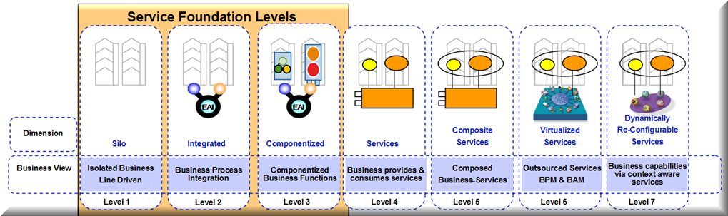
OSIMM Business Dimension

Business Dimension - Base Model Maturity Indicator
The base OSIMM model provides one of many possible maturity indicators per dimension. Organizations, vendors and consultants can provide additional maturity indicators, assessment questions and attribute mappings to provide additional guidance necessary for the maturation of an organization’s SOA.
The following Business Dimension maturity indicator is provided as part of the base OSIMM specification:
A SOA maturity assessment of the OSIMM Business Dimension is conducted by identifying the formal definition and documentation of the organization’s business drivers and processes.

Business Dimension - Assessment Questions
The following assessment questions help elicit information on how an organization formally defines and documents their business drivers and processes. By gathering information using these assessment questions an assessor can map a maturity indicator to the associated maturity attributes thereby determining the business dimension maturity level.
- What are the major business drivers for this initiative?
- What is the business vision and goals and how are these related to what IT is currently doing?
- Is your current Business Process Architecture formally defined, documented and governed?
- Is your Business Process Architecture complete & up to date?
- How are metrics for return on investment measured in Business Process Management?
- How agile are your current business processes?
- What are the current funding practices?
- What is the current cost model?
- Who owns the portfolio of processes, applications and services?
- Do you have a cost model to charge service consumers for the use of the service?
- How do you currently define the total cost of ownership(including software, hardware and future maintenance)?
- What level of partnership exists between the business stakeholders and the IT stakeholders?
- How are business service levels measured currently?
- What is the current practice to transform Business SLAs into IT SLAs?
- Do you have a formal Enterprise Architecture and Governance of your Enterprise Architecture?

Business Dimension - Maturity Indicator to Attribute Mapping
The following are the base set of maturity indicators for the OSIMM business dimension. Each Maturity Indicator is associated with a set of Maturity Attributes. Maturity Attributes are those observed characteristics of a maturity indicator for each maturity level. The assessment questions are used to survey an organization’s Business Dimension. Survey data obtained through the business dimension assessment questions are used to determine the maturity level by assessing the data and matching to the maturity attributes that best fit the information obtained. The maturity weighting is used to determine an average maturity score across multiple maturity indicators. The model can be extended by adding additional maturity indicators and assigning weighting to the indicator by maturity level according to the value placed on the maturity indicator by the assessing organization.

Maturity Indicators for the Business Dimension
Maturity Level  Cell Name | Maturity Indicator | Maturity Attributes | Maturity Weighting | Assessment Question Mapping
Siloed  (Level 1)  Isolated Business Line Driven | Formal definition and documentation of the organization’s business drivers and processes. | Low or Nonexistent  No formal Enterprise Architecture  Limited to how specific applications must behave, IT specific | 10 | 2, 3
Integrated  (Level 2)  Business Process Integration | Formal definition and documentation of the organization’s business drivers and processes. | Limited  No formal Enterprise Architecture  Limited to LOB objectives and need for information from other organizations. | 20 | 1, 2, 3, 4
Componentized  (Level 3)  Componentized Business | Formal definition and documentation of the organization’s business drivers and processes. | Cross-organizational  Some formal Enterprise Architecture constructs exists  Organizations business drivers are documented as cross organizational business objectives. | 30 | 1
Services  (Level 4)  Componentized Business Provides and Consumes Services | Formal definition and documentation of the organization’s business drivers and processes. | Enterprise-wide  Formal use of Enterprise Architecture  Organizations business drivers are documented as elements of the Enterprise Mission and Business Architecture | 40 | 1, 2, 3, 9, 10, 11
Composite Services  (Level 5)  Processes Provided and Consumed via Composite Business Services | Formal definition and documentation of the organization’s business drivers and processes. | Integrated Enterprise-wide  Formal use of Enterprise Architecture and BPM  Organizations business drivers are documented as elements of the Enterprise Mission and Business Architecture | 50 | 1, 5, 6, 9, 10, 11  2, 3, 8
Virtualized Services  (Level 6)  Outsourced services, BPM and BAM | Formal definition and documentation of the organization’s business drivers and processes. | Integrated across the Enterprise and externally between business partners  Well defined Enterprise Architecture that details both internal process flows as well as outsourced processes with and between business partner services. Strong use of BAM. | 60 | 5 ,6, 12
Dynamically Re-configurable Services  (Level 7)  Mix and Match Business Capabilities via Context-aware Services | Formal definition and documentation of the organization’s business drivers and processes. | Enterprise services on demand  Well defined Enterprise Architecture that includes a formal end-to-end definition of business process flow.  Business processes modeling is used to define and test process flows necessary to meet well defined SLA’s. | 70 | 5, 6, 13, 15  14

Organization & Governance Dimension – Base Model
This section defines the base model for the OSIMM Organization & Governance Dimension base model. The base model defines a set of generic maturity indicators and attributes that can be used to assess an organizations SOA maturity level against the OSIMM maturity matrix. Additional maturity indicators, assessment questions and attribute mappings can be added by vendors or user organizations to extend the base OSIMM model.
The assessment questions that follow help elicit how an organization formally defines and documents their organization and governance processes, which ranges from Ad hoc LOB IT strategy and governance driven to policy driven governance.
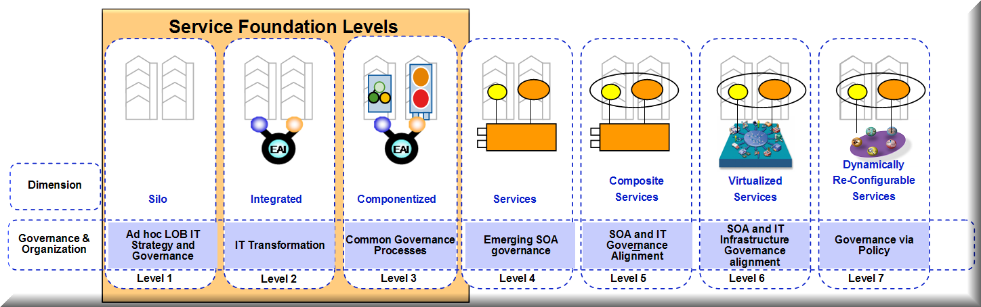
OSIMM Organization & Governance Dimension

Organization & Governance - Base Model Maturity Indicator
The base OSIMM model provides one of many possible maturity indicators per dimension. Organizations, vendors and consultants can provide additional maturity indicators, assessment questions and attribute mappings to provide additional guidance necessary for the maturation of an organization’s SOA.
The following Organization & Governance Dimension maturity indicator is provided as part of the base OSIMM specification:
A SOA maturity assessment of the OSIMM Organization & Governance Dimension can be conducted by identifying the formal use of SOA governance across the organization to develop, deploy and manage business and IT service..

Organization & Governance - Assessment Questions
By gathering information using these assessment questions, the Assessor, can map a maturity indicator to the associated maturity attributes thereby determining the Organization and Governance dimension maturity level.
- What types of skills are common in your IT staff?
- How does IT governance relate to your SOA?
- How is the IT governance related or aligned with the SOA, EA and the organization’s governance?
- Do SOA governance processes exist, are they documented and if so are they used for services at design time and run time?
- Is the interaction between organizations involved in the SOA process defined with clear roles and responsibilities?
- What are the governance functionalities and responsibilities?
- How would you describe your IT cost model?
- What type of SOA training is available in your IT organization?
- What is the relationship between the organization’s development team and the infrastructure team?
- What SOA and governance authorities exist?
- Do the organization’s SOA solutions cross organizational boundaries? Internally? Externally between business partners?

Organization & Governance Dimension – Maturity Indicator to Attribute Mapping
The following are the base set of maturity indicators for the OSIMM Organization & Governance dimension. Each Maturity Indicator is associated with a set of Maturity Attributes. Maturity Attributes are those observed characteristics of a maturity indicator for each maturity level. The assessment questions are used to survey an organization’s Organization & Governance Dimension. Survey data obtained through the Organization & Governance dimension assessment questions are used to determine the maturity level by assessing the data and matching to the maturity attributes that best fit the information obtained. The maturity weighting is used to determine an average maturity score across multiple maturity indicators. The model can be extended by adding additional maturity indicators and assigning weighting to the indicator by maturity level according to the value placed on the maturity indicator by the assessing organization.

Maturity Indicators for the Organization & Governance Dimension
Maturity Level  Cell Name | Maturity Indicator | Maturity Attributes | Maturity Weighting | Assessment Question Mapping
Siloed  (Level 1)  Ad hoc LOB IT Strategy and Governance | Formal use of SOA governance across the organization to establish, deploy and manage business and IT services. | Low or Nonexistent  A vision or strategy for the adoption of SOA does not exist. No recognition of the value of SOA Governance or nonexistent IT-business governance processes.  No-existent cross organizational (LOB) coordination of a SOA.  Minimal SOA training. | 10 | 2, 3, 4, 5  11  1, 8
Integrated  (Level 2)  IT Trans-formation | Formal use of SOA governance across the organization to establish, deploy and manage business and IT services. | Limited  A formal SOA strategy is evolving. Some cross organizational coordination.  SOA governance is limited to IT development process. No formal cross organizational SOA governance structures. | 20 | 2, 3, 4, 5, 11  6, 9, 10
Componentized  (Level 3)  Common SOA Governance Processes | Formal use of SOA governance across the organization to establish, deploy and manage business and IT services. | Cross-Organizational  A formalized SOA Strategy exits between one or more organizations.  SOA Governance has been established but has not been adopted holistically by the enterprise.  SOA training and skills are present but limited to IT practitioners.  Shared services may be evolving and governed between one or more LOBs. | 30 | 13  2, 3, 4, 5, 6  1, 8, 12
Services  (Level 4)  Emerging SOA Governance | Formal use of SOA governance across the organization to establish, deploy and manage business and IT services. | Enterprise-wide  A formal enterprise-wide SOA strategy and vision has been defined, published and agreed upon by the business units across the organization.  A formal SOA governance process and structure has been documented and is functioning among most business units.  Training programs have been tailored for IT and business unit needs. | 40 | 2, 3, 10  4, 5, 6  1, 6
Composite Services  (Level 5)  SOA and IT Governance Alignment | Formal use of SOA governance across the organization to establish, deploy and manage business and IT services. | Integrated Enterprise-wide  The use of SOA and shared services are an accepted element of the organizations strategy, business and IT models.  SOA Governance has been adopted across the enterprise by most organizations and is empowered to manage SOA services and solutions. | 50 | 2, 3  4, 9, 10
Virtualized Services  (Level 6)  SOA and IT Infrastructure Governance Alignment | Formal use of SOA governance across the organization to establish, deploy and manage business and IT services. | Integrated across the Enterprise and externally between business partners  SOA Governance is part of the organizational culture.  The organization treats SOA services as enterprise assets.  The organization has well defined SOA metrics and performance indicators. | 60 | 3  2  4
Dynamically Re-configurable Services  (Level 7)  Governance Implemented using Automated Policies | Formal use of SOA governance across the organization to establish, deploy and manage business and IT services. | Adaptive Enterprise  Services are modeled and managed as elements of the evolving business strategy.  Service metrics are automatically gathered and input to key business decisions. | 70 | 2, 3, 4, 5, 6  4

Methods Dimension – Base Model
This section defines the base model for the OSIMM Methods Dimension base model. The base model defines a set of generic maturity indicators and attributes that can be used to assess an organizations SOA maturity level against the OSIMM maturity matrix. Additional maturity indicators, assessment questions and attribute mappings can be added by vendors or user organizations to extend the base OSIMM model.
The following assessment questions help elicit the level of formality to which an organization has adopted a formal SOA Development and Deployment Methodology which ranges from structured design and analysis to business grammar oriented modeling.
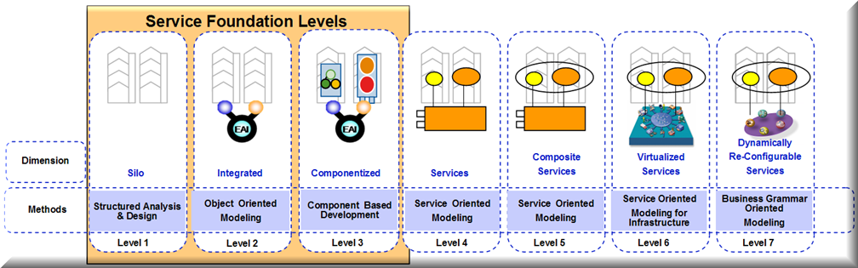
OSIMM Method Dimension

Method Dimension - Base Model Maturity Indicator
The base OSIMM model provides one of many possible maturity indicators per dimension. Organizations, vendors and consultants can provide additional maturity indicators, assessment questions and attribute mappings to provide additional guidance necessary for the maturation of an organization’s SOA.
The following Method Dimension maturity indicator is provided as part of the base OSIMM specification:
A SOA maturity assessment of the OSIMM Method Dimension can be conducted by identifying the formal use of an architectural design, construction and deployment methodology for the implementation of SOA services.

Method Dimension - Assessment Questions
By gathering information using these assessment questions an assessor can map a maturity indicator to the associated maturity attributes thereby determining the Method dimension maturity level.
- What are the current application or systems requirements elicitations and requirements management practices?
- What design methodologies and best practices are you currently adopting?
- Do you practice any SOA design techniques?
- What design tools are in practice today?
- What is the current practice for service development and management?
- What is your current project management framework?
- How is IT project management organized?
- What are your organization’s current QA processes?
- Do you have an active community that works to evolve your SOA methods and practices?
- Has your organization developed a repository for best practices and asset reuse?

Method Dimension - Maturity Indicator to Attribute Mapping
The following are the base set of maturity indicators for the OSIMM Method dimension. Each Maturity Indicator is associated with a set of Maturity Attributes. Maturity Attributes are those observed characteristics of a maturity indicator for each maturity level. The assessment questions are used to survey an organization’s Method Dimension. Survey data obtained through the method dimension assessment questions are used to determine the maturity level by assessing the data and matching to the maturity attributes that best fit the information obtained. The maturity weighting is used to determine an average maturity score across multiple maturity indicators. The model can be extended by adding additional maturity indicators and assigning weighting to the indicator by maturity level according to the value placed on the maturity indicator by the assessing organization.

Maturity Indicators for the Method Dimension
Maturity Level  Cell Name | Maturity Indicator | Maturity Attributes | Maturity Weighting | Assessment Question Mapping
Siloed  (Level 1)  Structured Analysis and Design | Formal use of an architectural design, construction and deployment methodology for the implementation of SOA services. | Low or Nonexistent  No formal use of SOA design and implementation methodology.  IT and business employees have little understanding or appreciation for implementing business processes as services. | 10 | 2, 3  5
Integrated  (Level 2)  Object Oriented Modeling | Formal use of an architectural design, construction and deployment methodology for the implementation of SOA services. | Limited  SOA methods and practices are limited to the IT development teams and have not been formalized across teams. | 20 | 1, 2, 3
Componentized  (Level 3)  Component Based Development | Formal use of an architectural design, construction and deployment methodology for the implementation of SOA services. | Cross-Organizational  SOA method and practices have been enhanced to address the creation, implementation and deployment of services. Methodology is largely focused on implementing IT infrastructure and integration services. | 30 | 1-5
Services  (Level 4)  Service Oriented Modeling | Formal use of an architectural design, construction and deployment methodology for the implementation of SOA services. | Enterprise-wide  SOA methods and practices have been implemented across the enterprise. Not all organizations follow a unified approach. | 40 | 1 - 5
Composite Services  (Level 5)  Service Oriented Modeling | Formal use of an architectural design, construction and deployment methodology for the implementation of SOA services. | Integrated Enterprise-wide  A formal and recognized methodology for the creation, development, deployment and management is in practice.  A recognized community is empowered to manage, train and update the enterprise SOA methods and practices. | 50 | 1, 2, 3  9
Virtualized Services  (Level 6)  Service Oriented Modeling for Infrastructure | Formal use of an architectural design, construction and deployment methodology for the implementation of SOA services. | Integrated across the Enterprise and externally between business partners  Formal methods are used to create and manage both internal and external (partner) based services.  Best practice guidance has been developed to facilitate consistent adoption of SOA and virtualization technologies, for example, ESB and Registry. | 60 | 1, 2, 3  9, 10
Dynamically Re-configurable Services  (Level 7)  Grammar Oriented Modeling | Formal use of an architectural design, construction and deployment methodology for the implementation of SOA services. | Adaptive Enterprise  Formal methods leverage architectural constructs and assets for supporting virtualization and dynamic services. | 70 | 1, 2, 3, 4, 5

Application Dimension – Base Model
This section defines the base model for the OSIMM Application Dimension base model. The base model defines a set of generic maturity indicators and attributes that can be used to assess an organizations SOA maturity level against the OSIMM maturity matrix. Additional maturity indicators, assessment questions and attribute mappings can be added by vendors or user organizations to extend the base OSIMM model.
The assessment questions that follow help elicit the level of formality to which an organization has successfully applied SOA application and system design, development and deployment principles and adopted SOA enabling technologies such as an ESB and service registry. Maturity ranges from application modules to dynamic application assembly.
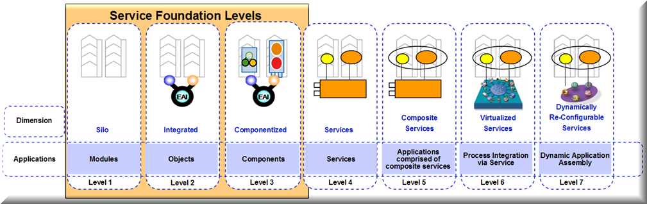
OSIMM Application Dimension

Application Dimension - Base Model Maturity Indicator
The base OSIMM model provides one of many possible maturity indicators per dimension. Organizations, vendors and consultants can provide additional maturity indicators, assessment questions and attribute mappings to provide additional guidance necessary for the maturation of an organization’s SOA.
The following Application Dimension maturity indicator is provided as part of the base OSIMM specification:
A SOA maturity assessment of the OSIMM Application Dimension can be conducted by identifying the application architectures that are designed and implemented using SOA principles and development practices and utilize constructs such as loose coupling, separation of concerns and employ the use of service enabled technologies such as XML, web services, service bus, service registries and virtualization.

Application Dimension - Assessment Questions
By gathering information using these assessment questions an assessor can map a maturity indicator to the associated maturity attributes thereby determining the Method dimension maturity level.
- What is your current application development style?
- How common is reuse in your organization?
- What types of reuse do you engage in and how is reusability measured?
- How are your organization’s applications / systems integrated?
- What types of languages does your organization use?
- What types of integration technologies has your organization employed?
- How is business logic represented within your organization’s applications?
- How reliable are your organization’s business-critical applications?
- How widely is XML used in your organization? How sophisticated is its use?
- What is the rate of change and required time to market of your current applications?

Application Dimension - Maturity Indicator to Attribute Mapping
The following are the base set of maturity indicators for the OSIMM Application dimension. Each Maturity Indicator is associated with a set of Maturity Attributes. Maturity Attributes are those observed characteristics of a maturity indicator for each maturity level. The assessment questions are used to survey an organization’s application or system architectures. Survey data obtained through the application dimension assessment questions are used to determine the maturity level by assessing the data and matching to the maturity attributes that best fit the information obtained. The maturity weighting is used to determine an average maturity score across multiple maturity indicators. The model can be extended by adding additional maturity indicators and assigning weighting to the indicator by maturity level according to the value placed on the maturity indicator by the assessing organization.

Maturity Indicators for the Application Dimension
Maturity Level  Cell Name | Maturity Indicator | Maturity Attributes | Maturity Weighting | Assessment Question Mapping
Siloed  (Level 1)  Modules | Application architectures are designed and implemented using SOA principles and development practices that utilize constructs such as loose coupling, separation of concerns and employ the use of service enabled technologies such as XML, web services, service bus, service registries and virtualization. | Low or Nonexistent  Application architectures and topologies are monolithic and lack integration between other systems across the enterprise.  The use of web services or other SOA constructs are not present. | 10 | 1  5
Integrated  (Level 2)  Objects | Application architectures are designed and implemented using SOA principles and development practices that utilize constructs such as loose coupling, separation of concerns and employ the use of service enabled technologies such as XML, web services, service bus, service registries and virtualization. | Limited  Application architectures and topologies are monolithic with minimal separation of concerns between architectural layers or application tiers.  Applications use minimal integration between other systems. Integration is usually implemented using point to point techniques. | 20 | 1, 2  3, 4
Componentized  (Level 3)  Components | Application architectures are designed and implemented using SOA principles and development practices that utilize constructs such as loose coupling, separation of concerns and employ the use of service enabled technologies such as XML, web services, service bus, service registries and virtualization. | Cross-Organizational  SOA development practices are applied inconsistently across the organization.  Most application architecture topologies have a separation of concerns both physically and logically in presentation, business logic and data tiers.  The use of SOA enabling technologies such as an ESB are used inconsistently across the enterprise. | 30 | 1, 2, 3, 4  5  6
Services  (Level 4)  Services | Application architectures are designed and implemented using SOA principles and development practices that utilize constructs such as loose coupling, separation of concerns and employ the use of service enabled technologies such as XML, web services, service bus, service registries and virtualization. | Enterprise-wide  Service components of application architectures employ SOA patterns such as separation of concerns between logical and physical layers of the presentation and business logic.  Service integration is achieved using an ESB in some but not all business units. | 40 | 1, 2, 3, 4  5, 6
Composite Services  (Level 5)  Applications Composed of Composite Services | Application architectures are designed and implemented using SOA principles and development practices that utilize constructs such as loose coupling, separation of concerns and employ the use of service enabled technologies such as XML, web services, service bus, service registries and virtualization. | Integrated Enterprise-wide  Application architectures are designed with a separation of concerns at the logical and physical layers.  ESB integration patterns are used to support application and process integration to achieve sharing of services. | 50 | 1, 2, 3  6
Virtualized Services  (Level 6)  Virtualized Services | Application architectures are designed and implemented using SOA principles and development practices that utilize constructs such as loose coupling, separation of concerns and employ the use of service enabled technologies such as XML, web services, service bus, service registries and virtualization. | Integrated across the Enterprise and externally between business partners  Application architecture is decoupled from infrastructure components.  Extensive use of ESB architecture patterns to support business process management. | 60 | 1, 2, 3, 10  6, 7, 8
Dynamically Re-configurable Services  (Level 7)  Dynamic Application Assembly, Context-aware Invocation | Application architectures are designed and implemented using SOA principles and development practices that utilize constructs such as loose coupling, separation of concerns and employ the use of service enabled technologies such as XML, web services, service bus, service registries and virtualization. | Adaptive Enterprise  Application architecture supports dynamically reconfigurable business and infrastructure services and SOA solution for internal or external partner consumption. | 70 | All

Architecture Dimension – Base Model
This section defines the base model for the OSIMM Architecture Dimension base model. The base model defines a set of generic maturity indicators and attributes that can be used to assess an organizations SOA maturity level against the OSIMM maturity matrix. Additional maturity indicators, assessment questions and attribute mappings can be added by vendors or user organizations to extend the base OSIMM model.
The assessment questions that follow help elicit the level of formality to which an organization has formally adopted SOA design methods, principles and frameworks. Maturity ranges from monolithic architecture to dynamically reconfigurable architecture.
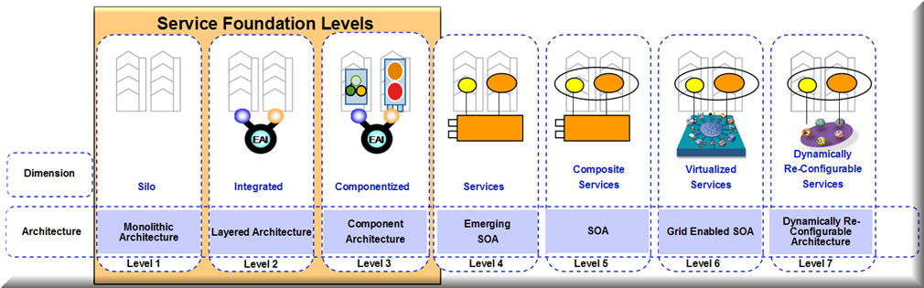
OSIMM Architecture Dimension

Architecture Dimension - Base Model Maturity Indicator
The base OSIMM model provides one of many possible maturity indicators per dimension. Organizations, vendors and consultants can provide additional maturity indicators, assessment questions and attribute mappings to provide additional guidance necessary for the maturation of an organization’s SOA.
The following Architecture Dimension maturity indicator is provided as part of the base OSIMM specification:
A SOA maturity assessment of the OSIMM Architecture Dimension can be conducted by identifying those service components that have been designed and are deployed using formal SOA methods, principles, patterns, frameworks or techniques.

Architecture Dimension - Assessment Questions
By gathering information using these assessment questions an assessor can map a maturity indicator to the associated maturity attributes thereby determining the Architecture dimension maturity level.
- How would you characterize your architectural topologies?
- What type(s) of data repositories does your organization utilize?
- What is the standard communication style in your architecture?
- How is integration achieved in your architecture?
- What methods do you use to develop your architecture?
- How mature are your services implementations?
- How extensive is your SOA?
- What architectural principles define your approach?
- How extensive and sophisticated is your organization's use of frameworks in your architecture?
- How are architectural decisions made in your organization?
- Does your organization use reference architectures?

Architecture Dimension - Maturity Indicator to Attribute Mapping
The following are the base set of maturity indicators for the OSIMM Architecture dimension. Each Maturity Indicator is associated with a set of Maturity Attributes. Maturity Attributes are those observed characteristics of a maturity indicator for each maturity level. The assessment questions are used to survey an organization’s Architecture Dimension. Survey data obtained through the method dimension assessment questions are used to determine the maturity level by assessing the data and matching to the maturity attributes that best fit the information obtained. The maturity weighting is used to determine an average maturity score across multiple maturity indicators. The model can be extended by adding additional maturity indicators and assigning weighting to the indicator by maturity level according to the value placed on the maturity indicator by the assessing organization.

Maturity Indicators for the Architecture Dimension
Maturity Level  Cell Name | Maturity Indicator | Maturity Attributes | Maturity Weighting | Assessment Question Mapping
Siloed  (Level 1)  Monolithic Architecture | Service components are designed using formal SOA methods, principles, patterns, frameworks or techniques. | Low or Nonexistent  No SOA methods or practices are apparent. | 10 | 1
Integrated  (Level 2)  Layered Architecture | Service components are designed using formal SOA methods, principles, patterns, frameworks or techniques. | Limited  Limited use of formal SOA methods and practices can be observed.  Methods and practices are limited to integration between applications or systems. | 20 | 1, 2  8, 9
Componentized  (Level 3)  Component Architecture | Service components are designed using formal SOA methods, principles, patterns, frameworks or techniques. | Cross-Organizational  Formal SOA methods and practices are employed by multiple groups within the enterprise.  The organization has a loosely defined Enterprise Architecture supported by limited tooling and governance practices. | 30 | 4, 5, 6, 7, 8
Services  (Level 4)  Emerging SOA | Service components are designed using formal SOA methods, principles, patterns, frameworks or techniques. | Enterprise-wide  Formal SOA methods and practices are employed across the enterprise supported by a formal governance process.  Applications and services are designed using formal SOA principles and patterns. | 40 | 4, 5, 6,  7, 8
Composite Services  (Level 5)  SOA | Service components are designed using formal SOA methods, principles, patterns, frameworks or techniques. | Integrated Enterprise-wide  Enterprise frameworks and practices supported by the use of a formal SOA method and reference architectures across the enterprise.  A formal enterprise business information model is evolving. | 50 | 7, 8, 9  2, 10
Virtualized Services  (Level 6)  Grid Enabled SOA | Service components are designed using formal SOA methods, principles, patterns, frameworks or techniques. | Integrated across the Enterprise and externally between business partners  Service components are designed using formal methods, practices and frameworks that promote the reuse of assets.  Formal enterprise wide business information services has been developed and deployed | 60 | 1, 3, 4, 5, 6  2, 10, 11
Dynamically Re-configurable Services  (Level 7)  Dynamically Re-Configurable Architecture | Service components are designed using formal SOA methods, principles, patterns, frameworks or techniques. | Adaptive Enterprise  Service components are designed using formal SOA methods, principles, patterns, frameworks or techniques.  Formal enterprise business information services have been designed and implemented that includes both enterprise and external relationship entities | 70 | 1, 3, 4, 5, 6  2, 10, 11

Information Dimension – Base Model
This section defines the base model for the OSIMM Information Dimension base model. The base model defines a set of generic maturity indicators and attributes that can be used to assess an organizations SOA maturity level against the OSIMM maturity matrix. Additional maturity indicators, assessment questions and attribute mappings can be added by vendors or user organizations to extend the base OSIMM model.
The assessment questions that follow help elicit the level of formality to which an organization has successfully applied SOA application (or system) design, development and deployment principles and adopted SOA enabling technologies such as an ESB and service registry. Maturity ranges from application specific data solution to semantic data vocabularies.
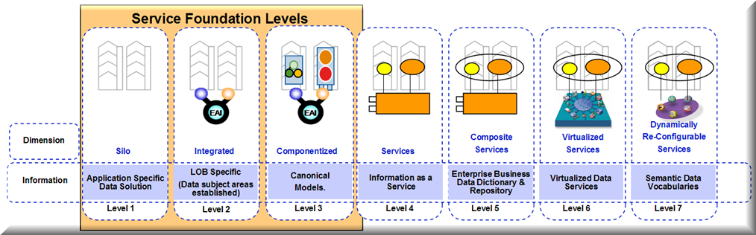
OSIMM Information Dimension

Information Dimension - Base Model Maturity Indicator
The base OSIMM model provides one of many possible maturity indicators per dimension. Organizations, vendors and consultants can provide additional maturity indicators, assessment questions and attribute mappings to provide additional guidance necessary for the maturation of an organization’s SOA.
The following Information Dimension maturity indicator is provided as part of the base OSIMM specification:
A SOA maturity assessment of the OSIMM Information Dimension can be conducted by identifying the information architecture that supports a master data model (federated data service and implements a common business data vocabulary.

Information Dimension - Assessment Questions
By gathering information using these assessment questions an assessor can map a maturity indicator to the associated maturity attributes thereby determining the Information dimension maturity level.
- Is there a common data model across all applications?
- Are there independent data models for different applications?
- Are mapping rules used to convert between different data models?
- Is there difficulty in moving data from one application to another? For all applications? For only some applications?
- Does your organization have a common data model, (or mappings between multiple data models), how is this defined? By programming objects in APIs? By XSD schemas? By written documents? By other computer-based modeling tools? By other non-computer-based modeling tools?
- Are the Data Models in the form of Business Object Models, understandable to and owned by, the Business, or as IT object models, understandable only to, and owned by, the IT teams?
- If there are mapping rules across different models, are these understandable to and maintained by the business or by IT staff? Are such mapping rules performed by the infrastructure?
- Are the data models defined by a language that includes taxonomies, ontologies, or other high-level logical representations?
- Do you maintain a global directory or database of data objects, with global identifiers? Or do you have mechanisms for mapping these objects between different databases/directories? Are these mechanisms electronic or manual? Are all such objects mapped, or is this done only for certain applications and sets of objects? Are these mappings undertaken automatically by the infrastructure?
- Do you have mechanisms for looking up global objects by searching on their characteristics?
- How is the transformation of data between applications achieved? Is an ESB used to perform the transformation? Is this achieved by bespoke adapters as required? Or via a comprehensive set of APIs? Or by calling a service?
- Are there facilities for performing complex inference in order to map data defined in ontologies from one form to another? Does a master-data service exist?
- Does your organization have or are you developing a Business Information Model to standardize data and message formats and concepts across the enterprise?

Information Dimension - Maturity Indicator to Attribute Mapping
The following are the base set of maturity indicators for the OSIMM Information Dimension. Each Maturity Indicator is associated with a set of Maturity Attributes. Maturity Attributes are those observed characteristics of a maturity indicator for each maturity level. The assessment questions are used to survey an organization’s Information Dimension. Survey data obtained through the Information Dimension assessment questions are used to determine the maturity level by assessing the data and matching to the maturity attributes that best fit the data obtained. The maturity weighting is used to determine an average maturity score across multiple maturity indicators. The model can be extended by adding additional maturity indicators and assigning weighting to the indicator by maturity level according to the value placed on the maturity indicator by the assessing organization.

Maturity Indicators for the Information Dimension
Maturity Level  Cell Name | Maturity Indicator | Maturity Attributes | Maturity Weighting | Assessment Question Mapping
Siloed  (Level 1)  Application Specific Data Solution | The information architecture supports a master data model that implements a common business data vocabulary. | Low or Nonexistent  Information is replicated and redundant. Conceptual enterprise information model is absent. | 10 | 1 - 5
Integrated  (Level 2)  LOB or Enterprise Specific | The information architecture supports a master data model that implements a common business data vocabulary. | Limited  Information is shared across some applications using Extraction, Transformation, Load, Manipulate (ETLM) or message oriented technologies. Initial data vocabularies are beginning to emerge. | 20 | 1 – 5, 11
Componentized  (Level 3)  Canonical Models | The information architecture supports a master data model that implements a common business data vocabulary. | Cross-Organizational  Business data vocabularies have emerged but are application or system specific.  Formal business information models have emerged often accessed though XML schema style interfaces. | 30 | 1 - 6
Services  (Level 4)  Information as a Service | The information architecture supports a master data model that implements a common business data vocabulary. | Enterprise-wide  Multiple business units are using meta-data relationships.  Business data vocabularies are standardized within a business unit or process area.  Business data can be shared within a business unit and with business partners in a consistent manner. Interfaces are defined using common message data vocabularies. | 40 | 5  6
Composite Services  (Level 5)  Business Data Dictionary and Repository | The information architecture supports a master data model that implements a common business data vocabulary. | Integrated Enterprise-wide  Information services are in place such as data validation, data cleansing, data transformation, partner data integration or others.  Master data services are in place and are utilized across the enterprise.  Business data vocabularies are standardized for use across the enterprise. | 50 | 7, 8, 9  11
Virtualized Services  (Level 6)  Virtualized Information Services | The information architecture supports a master data model that implements a common business data vocabulary. | Integrated across the Enterprise and externally between business partners  Business data vocabularies can be expanded and enhanced as required to support new services, external partners and business process reconfiguration.  A registry with metadata is used to manage enterprise service assets.  A formal enterprise wide business information model has been developed and deployed. | 60 | 7, 8, 9  10, 11, 12  13
Dynamically Re-configurable Services  (Level 7)  Semantic Data Vocabularies | The information architecture supports a master data model that implements a common business data vocabulary. | Adaptive Enterprise  Business data vocabularies can easily be expanded and enhanced as required to support new services, external partners and business process reconfiguration.  Business data is defined using semantic web constructs, or Ontologies (e.g., UN/CEFACT Core Components, ISO 11179)  A formal enterprise business information model has been designed and implemented that includes both enterprise and external relationship entities. | 70 | 1-9  8, 9, 10, 11, 12  13

Infrastructure & Management Dimension – Base Model
This section defines the base model for the OSIMM Infrastructure & Management Dimension base model. The base model defines a set of generic maturity indicators and attributes that can be used to assess an organizations SOA maturity level against the OSIMM maturity matrix. Additional maturity indicators, assessment questions and attribute mappings can be added by vendors or user organizations to extend the base OSIMM model.
The assessment questions that follow help elicit the level of formality to which an organization has successfully applied SOA application and system design, development and deployment principles and adopted SOA enabling technologies such as an ESB and service registry. Maturity ranges from LOB platform specific to context-aware event-based sense and respond.
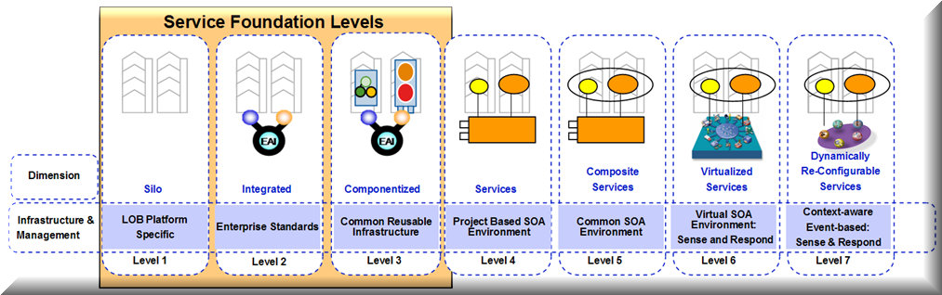
OSIMM Infrastructure & Management Dimension

Infrastructure & Management Dimension - Base Model Maturity Indicator
The base OSIMM model provides one of many possible maturity indicators per dimension. Organizations, vendors and consultants can provide additional maturity indicators, assessment questions and attribute mappings to provide additional guidance necessary for the maturation of an organization’s SOA.
The following Infrastructure and Management Dimension maturity indicator is provided as part of the base OSIMM specification:
A SOA maturity assessment of the OSIMM Infrastructure and Management Dimension can be conducted by identifying the IT Infrastructure that supports the non-functional and operational requirements and service-level agreements needed to operate a SOA environment.

Infrastructure & Management Dimension - Assessment Questions
By gathering information using these assessment questions an assessor can map a maturity indicator to the associated maturity attributes thereby determining the Infrastructure & Management dimension maturity level.
- What are your current infrastructure usage guidelines?
- How are your IT SLAs derived from the business SLAs?
- Have you defined SLAs around Quality of Service? How is this monitored and measured?
- Have you defined any SLAs around security and privacy? How is this measured and monitored?
- What level of monitoring is in place today? What management tools are in place today?
- What platforms are currently in use for integration?
- Which assets are placed under version control?
- What is your current change management process?
- What tools are used for configuration management?
- What are considered as your organization's IT assets? (excluding human resource) How are these assets managed?
- What does your current operational architecture look like?
- How does your operational architecture support the NFRs for applications and services?

Infrastructure & Management Dimension - Maturity Indicator to Attribute Mapping
The following are the base set of maturity indicators for the OSIMM Infrastructure & Management dimension. Each Maturity Indicator is associated with a set of Maturity Attributes. Maturity Attributes are those observed characteristics of a maturity indicator for each maturity level. The assessment questions are used to survey an organization’s Infrastructure & Management Dimension. Survey data obtained through the method dimension assessment questions are used to determine the maturity level by assessing the data and matching to the maturity attributes that best fit the information obtained. The maturity weighting is used to determine an average maturity score across multiple maturity indicators. The model can be extended by adding additional maturity indicators and assigning weighting to the indicator by maturity level according to the value placed on the maturity indicator by the assessing organization.

Maturity Indicators for the Infrastructure & Management Dimension
Maturity Level  Cell Name | Maturity Indicator | Maturity Attributes | Maturity Weighting | Assessment Question Mapping
Siloed  (Level 1)  LOB Platform Specific | The IT Infrastructure supports the non-functional and operational requirements and service-level agreements needed to operate a SOA environment. | Low or Nonexistent  Little or nonexistent operating support for the deployment of services. | 10 | 1, 5, 6, 7, 8, 9, 11
Integrated  (Level 2)  Platform Specific | The IT Infrastructure supports the non-functional and operational requirements and service-level agreements needed to operate a SOA environment. | Limited  Messaging solutions exist to integrate applications and supports the migration to an ESB.  Service management and service security are partially implemented. | 20 | 6  4
Componentized  (Level 3)  Common reusable Infrastructure | The IT Infrastructure supports the non-functional and operational requirements and service-level agreements needed to operate a SOA environment. | Cross-Organizational  Processes for service management and security have been published and are in use for the business unit or enterprise. | 30 | 1,3,5
Services  (Level 4)  Project Based SOA Environment | The IT Infrastructure supports the non-functional and operational requirements and service-level agreements needed to operate a SOA environment. | Enterprise-wide  Operating environment supports enterprise-wide service deployment. Identities of distributed users across departmental, organizational and enterprise boundaries can be administered and managed. | 40 | 3,4,11
Composite Services  (Level 5)  Common SOA Environment | The IT Infrastructure supports the non-functional and operational requirements and service-level agreements needed to operate a SOA environment. | Integrated Enterprise-wide  Service management supports quality of services and composite applications.  Security policies are managed and enforced. | 50 | 3  4
Virtualized Services  (Level 6)  SOA Environment Sense and Respond | The IT Infrastructure supports the non-functional and operational requirements and service-level agreements needed to operate a SOA environment. | Integrated across the Enterprise and externally between business partners  Services as resources can be virtualized such that an instance may be deployed across multiple runtime environments.  Service monitoring and performance management supports deployment of new services. | 60 | 5  5
Dynamically Re-configurable Services  (Level 7)  Context-aware Event-based Sense and Respond | The IT Infrastructure supports the non-functional and operational requirements and service-level agreements needed to operate a SOA environment. | Adaptive Enterprise  Service management tracks and predicts changes to services necessary to optimize service quality.  Services can be reused in new and dynamic ways without negatively impacting the QoS of existing services.  Service security policies are dynamic and managed in real time. | 70 | 2, 3  4  5

The OSIMM Assessment Method
OSIMM may be used to support an SOA assessment of an single project or for an entire line of business, the entire enterprise, a service eco-system, or industry. The purpose of the OSIMM assessment method is to assess the current maturity and determine the target maturity level (goal state) necessary to meet stated business objectives.
Extending the OSIMM model to assess maturity against additional maturity indicators such as SOA industry frameworks is expected and encouraged. The OSIMM Assessment Method is iterative and evolutionary. As an organization adopts a SOA strategy, becomes more familiar with OSIMM assessments, and accumulates experience implementing SOA systems, it may add its own maturity indicators to the model.
The value of OSIMM as an assessment tool is to provide SOA transformation and adoption guidance for the SOA governance process.

Overview
Analysis consists of the following three activities:
- assessment of the current maturity levels of the business, organization and IT
- goal state identification and definition, building a vision of what the organization’s business, processes, staff and IT solutions would look like if they were transformed to a highly-capable Services Oriented Architecture
- production of the recommendation report which identifies the current maturity levels of the various domains, describes the ideal goal state, and defines a roadmap showing how to advance to that goal state
These activities are performed in an OSIMM analysis, which has the following steps:
- Identify the business objectives relevant to the target assessment (use Enterprise Architecture artifacts as input).
- Extend the OSIMM model by adding the desired maturity indicators.
- Add desired attributes for the maturity indicators at each maturity level. Extending the base OSIMM model with additional maturity indicators allow the organization to link SOA adoption to its strategy thereby alleviating pain points or adding business capability.
- Assess the current maturity level by comparing the current state of the organization’s SOA adoption against the maturity indicators by mapping them to the corresponding maturity attributes.
- Determine the goal state maturity levels by considering the required level of SOA maturity necessary to achieve the stated business goals.
- Compare the current and target level maturity indicators to identify gaps and determine the organization’s transformation roadmap from current maturity to desired target.
- Document the assessment and the transformation roadmap in the assessment report.
Figure 3.1 depicts the OSIMM assessment process as outlined above.

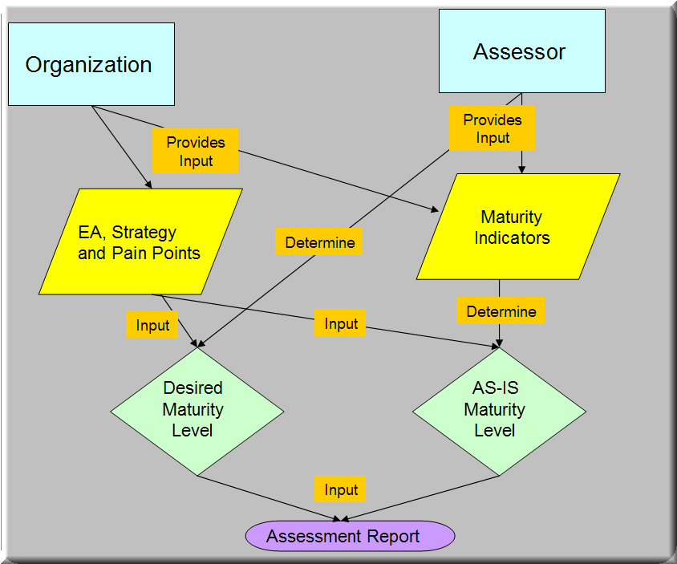
Figure 3.1 – OSIMM Analysis Process

OSIMM Assessment Steps

Identify the Pain Points, Scope and Business Goals
Pain points define where the organization considers that its processes need to be improved, and can be used to focus the subsequent OSIMM analysis. The assessor should gather material that can help determine the desired goal states of the SOA maturity levels. This material includes strategy documents, user requirements and Enterprise Architecture artifacts. At this stage an initial list of pain points or strategic goals is determined. Once this is done the scope and structure of the SOA roadmap and transformation can be determined. The dimensions and domains in the OSIMM may be used to assist the definition of the scope.

Extend the OSIMM Model
On the basis of the agreed scope and objectives, an assessment matrix must be created, based upon the full OSIMM matrices, but tailored to focus on the key pain points. The OSIMM model may be extended by adding additional maturity indicators. Additional maturity indicators can be used to focus on specific pain points or strategic requirements for the adoption of services. This requires the assessment team to carefully map maturity attributes to any additional maturity indicators. Adding maturity indicators to the OSIMM base model should be conducted by experienced SOA practitioners.

Assess Current State
The assessor uses the extended OSIMM model produced in the previous step to interview key staff in the organization in order to assess the current state of the organization and hence its current maturity level. The interviews should be based upon the base assessment questions provided within OSIMM and assessment questions added as part of the extension, and can include additional questions considered relevant by the assessor that may help to map indicators to maturity attributes.. On the basis of the answers to the assessment questions, the current maturity level is determined for each domain, and aggregated through the dimensions to the overall state of the organization.

Determine Future State
The future desired state is determined using requirements documents, EA artifacts and from interviews with the key staff. It is important to focus on those individuals who possess a good understanding and vision of the future requirements for business based services and SOA infrastructure. The desired future state is determined by assessing the ROI for higher level SOA maturity within each OSIMM dimension against business requirements.

Identify the Gaps and Determine the Road map
The previous steps have identified the current and future maturity levels across all of the domains and dimensions in the assessment matrix created in the first step. The assessor should now determine the gaps between the current and future maturity levels, and create a roadmap that takes the organization from current to target. The maturity indicators for each domain must show the current and desired state, and the steps in the road map must be constructed in order to take the domains from current to desired, and to achieve business objectives or alleviate pain points. The assessor should also consider constraints and prerequisites that will exist between the different IT and business entities that need to be put in place. It should be noted that the output of the OSIMM road map is intended to provide a relatively high level statement of the activities that need to be undertaken, and that further more detailed analysis can be undertaken, outside of the OSIMM analysis, of the precise nature of the activities.
The conclusions of the OSIMM assessment, including pain points, assessment matrix, current maturity level, future maturity level, alleviation of pain points and road map, should be documented in a report to be used to guide the next stage of analysis and planning and provide input into future SOA roadmaps, SOA Governance activities, and Enterprise Architecture spirals.
- Appendix A – Example Assessment
This Appendix illustrates the use of the OSIMM by describing an example assessment. The company described – HEALTHCO - is fictional. The assessment is described at an outline level, showing the main features of the method, but not the details of the specific indicators, attributes, weightings, and assessment questions.
  - Business Objective
HEALTHCO, a company providing health care services, envisioned a Service-Oriented Architecture to drive integration, promote a common business and IT vision, and optimize IT spending to support its business goals. To accomplish this vision, HEALTHCO needed to identify gaps in its current IT environment from the service integration maturity perspective. OSIMM was used to assess the current state, determine the target state and develop recommendations across the OSIMM dimensions.
  - Analysis
In the example, a number of applications were divided into two groups, front end and legacy, and an OSIMM Analysis was performed. The steps, focusing on the Business dimension, are summarized below, and illustrated in Figure A:1.
- A pain point is that the business perceives IT as not being agile enough to support the introduction of new business processes
- By analyzing the maturity indicators, it is determined that the business sees IT as applications rather than composite services that can be created from other services.
- This places the organization currently at level 2 on the business dimension
- The applications are monolithic and are not integrated with other systems.
- By considering the characteristics of different levels as defined in OSIMM, it can be seen that business at level 5 will alleviate the pain point reason by facilitating the design of new business processes from services
- The need to go from level 2 to (at least) level 5 in the business dimension suggests a step in the road map of introducing business processes and services to structure the functionality.
  - Recommendations
The recommendations are summarized in the following table, together with the current and target maturity levels for each of the dimensions:

OSIMM Dimension | Current Maturity Level | Summarized Assessment | Target Maturity Level | Recommendations
Business View | 2 | Strengths:  - Business has good understanding of IT capabilities.  Weaknesses:  - Business views IT as a set of applications that deliver capabilities to support business processes.  - Business capabilities are not aligned with IT.  - Application interdependencies and complexities affect business agility. | 6 | A componentized view of the business capabilities should be developed in which business views services as assets that transcend the current application-centric views.
Organization | 3 | Strengths:  - Cross-application organization is in place.  - Responsibility for service enablement is managed  Weaknesses:  - The IT organization is mostly application-centric with specialized skills to manage the development and support for specific applications. | 4 | Business owners should drive changes to services, business processes, and the component architecture to meet changing business needs.  IT owners should be assigned to support specific business capability areas and their business owners.  Business capability owners should be enabled to focus more on sustaining and improving specific capabilities.
Methods | 2 | Strengths:  - IT planning and governance process in place.  - Consistent Development methodology followed.  - OO design and development practices are in place for front-end applications  - Services standards and guidelines are published.  Weaknesses:  - Planning and development process does not support services modeling or code reuse, with limited support for business process modeling  - Planning and development process is heavyweight and waterfall-based. | 4 | Enhance planning and development methods to support services identification, design and development.  Introduce services governance process.  Enhance planning and development processes to encourage and promote code reuse.  Enhance planning and development processes to support iterative development.  Enhance the software development method to support Business Process Modeling and implementation.
Infrastructure | 3 | Strengths:  - System management software is in place.  - Security infrastructure is in place.  Weaknesses:  - SOA-specific infrastructure (Services management, Business process management) is absent. | 5 | Deploy web services management infrastructure to support enterprise-scale SOA deployment.  Deploy Business Process Management infrastructure.  Deploy SOA security infrastructure to be able to support security policies defined at the service level.
Applications  (Front End) | 3 | Strengths:  - Architecture is componentized and layered  - Object models used  Weaknesses:  - Minimal code reuse.  - Object models not shared and are developed independently  - BPM/Workflow is custom or not in place.  - Application architecture is not standardized. | 5 | Implement enterprise domain object model.  Introduce code reuse at the component and library level.  Standardize reference application architecture, design patterns and best practices.  Implement business rules engine.  Modernize and componentize COBOL applications.
Applications (Legacy) | 2 | Strengths:  - Efforts are in place to modernize the application architecture.  - Legacy Access views provide a consistent approach for code reuse.  Weaknesses:  - COBOL legacy architecture difficult to change.  - No consistent approach for system componentization.  - BPM/Workflow is custom or not in place.  - Application architecture is not standardized and does not address back-end applications. | 5
Architecture Integration and Services (Front End) | 3 | Strengths:  - Most applications consume Legacy access views using standard approach.  - Some applications act as service providers.  - WSDL files published within each application.  Weaknesses:  - Point-to-point integration.  - Different protocols and translation mechanisms used for mainframe integration.  - Security architecture is inconsistent | 5 | Implement reusable business services.  Implement Enterprise Integration Data Model (Canonical Data Model).  Implement uniform transport protocol for Web services.  All communications with internal and external systems should be handled by ESB  Support legacy consumers using ESB.  Implement some of the application components as coarse-grained service components where component's interfaces are exposed using Web services.  All applications, including mainframe back-end systems, communicate via Web services as opposed to reusing copybooks and Legacy Access views directly. COBOL applications should be able to act as consumers of Web services provided by other back-end systems.  SOA must provide the support for batch processing; batch processing should be implemented "on the side."  Design and implement security policies at the service level.
Architecture Integration and Services (Legacy) | 3 | Strengths:  - Legacy Access views are used to provide services to other applications and are documented  - An approach is in place to make the Legacy Access views available to consuming systems.  - ESB implemented.  Weaknesses:  - Back-end systems tightly coupled.  - Some Legacy Access views not generic.  - No enterprise data model for system integration.  - Business functions are duplicated in multiple systems.  - Heavy reliance on batch feeds.  - Security architecture is inconsistent | 5

- APPENDIX B – Benefits of Moving to Higher Maturity Levels
  - Benefits of moving from Silo to Integrated
Organizations transforming from a Silo maturity level to an Integrated maturity level will significantly reduce operational and maintenance cost. These cost reductions are realized by reducing redundant and laborious data entry processes, reducing batch cycles to transform and transfer the data from one system to another. From this transition the data is available on a real-time basis, with reliable delivery of data and automated data format conversion for the integrating systems. The transformation from structured programming to object oriented programming would also leverage reusability of the code and help in reusability and reduction of the software maintenance complexities since the software is more modular. The modular code increases readability of the code thus reducing maintenance time.
  - Benefits of moving from Integrated to Componentized
Organizations transforming from an Integrated maturity level to a Componentized maturity level would benefit in preparing themselves to expose the business functionality at more granular level, such exposure is required at more advanced maturity levels. The reusability also matures to be at a business function level as compared to application level and enhancements and new functionality is achieved through refactoring of the existing applications into smaller re-useable components. The disaggregation of the business in itself helps in reducing the complexities and facilitates the analysis of the impact of the componentized organization on new business models and business transformations. This componentization also helps the organization in reducing the time to market and increases IT response to business changes.
  - Benefits of moving from Componentized to Services
The transformation from a Componentized maturity level to a Service maturity level makes the organization be viewed more as a service provider to other organizations within the enterprise or external to the enterprise participating in the value chain. Business services now become reusable. This maturity level reduces the need for (and hence the cost of) redeveloping the same functionality for multiple systems by the provision of re-useable services called through standardized interfaces, irrespective of the technology platform on which the application is running. These services can also offer access to data in a controlled and timely manner which reduces inconsistencies in the data within systems that access and update it. The investment of effort in identification, specification, development, testing and deployment of a service is paid back when new systems require the same service from the providing organization, since the cost of infrastructure and maintenance of common functionality is reduced.
  - Benefits of moving from Services to Composite Services
Organizations transforming from a Service maturity to a Composite Service maturity level have structured their business and IT support so that new business processes may be more rapidly constructed out of services, and provision of new business functionality to different parts of the organizations may be achieved more easily. This also reduces the time to market a new business model due to a change in business strategy and or business transformation. At this level of transformation it is primarily a re-composition of the services provided by different organizations within an enterprise of the value chain of the enterprise.
  - Benefits of moving from Services to Virtualized Services
Organizations transforming from a Composite Service maturity to a Virtualized Service maturity level benefit from a significant degree of flexibility in the design of integrated systems, in that different types of service (in terms of protocol, data models etc) that would otherwise not be interoperable can be more easily integrated. In addition, system may be reconfigured to achieve higher reliability, without the consumers having to modify their code. Virtualized services will enable organizations to better align business requirements with IT capabilities by building robust services that are highly flexible, manageable and scalable consistently.
  - Benefits of moving from Virtualized Services to Dynamically Re-Configurable Services
Organizations achieving this level of maturity would have completely decomposed services with service configuration information stored in a database for the service to be dynamically configured based on the dynamic nature of service requests. This provides a superior flexibility for business transformation and provides a complete business and IT alignment. This provides autonomic features for the infrastructure to sense and respond to service requests within the organization and enterprise with high resiliency.
Organizations at this level of maturity would have services that provide an agile capability to meet SLA’s by allocating capacity dynamically with increased flexibility, which makes the organization highly competitive. This capability would also enable the Organization to optimize services for high availability and scalability without impacting service levels and reduces the complexity of deploying services.

- References
The following documents are referenced herein:
- TOGAF – TOGAF Specification - http://www.opengroup.org/architecture/togaf9-doc/arch/
- SOA Definition, Open Group SOA Work Group - http://www.opengroup.org/projects/soa/doc.tpl?gdid=10632

Index -
Error! No index entries found.

